Liquorice Glycyrrhiza glabra
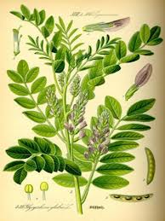
Liquorice has been used
- as an expectorant (clears catarrh)
- antitussive (stops subsequent coughing)
- demulcent (good for sore mouths)
- spasmolytic (good for stomach ache)
- a mild laxative.
Liquorice also has a very important action in raising cortisol levels by inhibiting 11β-hydroxysteroid dehydrogenase the enzyme responsible for breaking down cortisol in the kidney.
- Liquorice has therefore been used in the treatment of inflammatory and autoimmune disease.
- This cortisol like action of liquorice is responsible for it’s most serious toxic effects, high blood pressure and low potassium levels.

